8.28: a) From Taking positive velocities to the right, 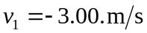 and 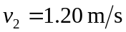, so 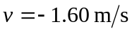.

b) 